How do YOU join FFA? Pay your FFA dues soon.
Anyone in an Ag class may join by paying your dues of only $25!
Your dues must be paid in order to become a Cy Falls FFA member. This simple fee must be paid in order to participate in any FFA activities, including showing an animal for Cy Falls. Some of the activities we will be offering include:
- Spring Career Development Events (CDE’s)
  - Livestock Judging
  - Horse Judging
  - Land Judging
  - Dairy Cattle Judging
  - Vet Med
  - Entomology
  - Homesite
  - Floral
  - Wool
- Other FFA Activities
  - Greenhand Social
  - Craft Show
  - FFA Banquet
  - Tour Guiding
  - Scholarships
- Fall Leadership Development Events (LDE’s)
  - Public Relations
  - Skills Team
  - Quiz Team
  - Radio Team
  - Creed Speaking
  - Job Interview
  - Ag Issues/Advocacy

- Fall Livestock Trips
  - State Fair of Texas
  - Washington Co. Fair

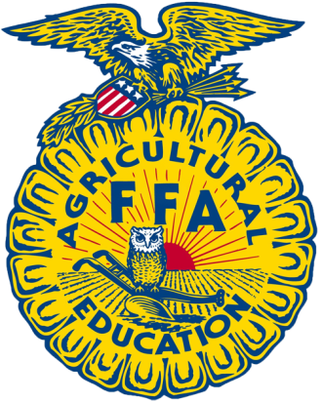
And so much More…….
- National FFA Dues
- State FFA Dues
- Area III Dues
- District VII Dues

