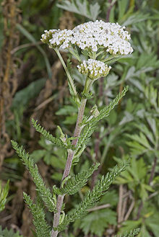
Yarrow

Achillea filipendulina

Genus: Achillea
Common Name: Yarrow
Species: filipendulina
Availability: July- September
Cut life: 7-10 days
Size: Up to 4 ft.
Colors Available: Yellow, pink, red, white
Growing Conditions: Full sun and regular water, do not over water though!

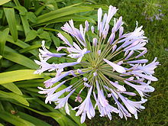
Agapanthus

Agapanthus africanus

Genus: Agapanthus
Common Name: Agapanthus
Species: africanus
Availability: March-August
Cut life: 5-10 days
Size: 25-60 cm tall
Colors Available: Blue, white
Growing Conditions: Full sun to partial shade, medium water.

Alstroemeria

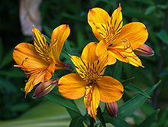
Alstroemeria aurantiaca

Genus: Alstroemeria
Common Name: Alsroemeria
Species: aurantiaca
Availability: Year- Around
Cut life: Stem-2weeks, Individual flower 5-7 days
Size: Up to 3 ft.
Colors Available: Multiple mixed colors
Growing Conditions: Full sun to light shade, regular water,
likes well drained soil, constantly moist!

