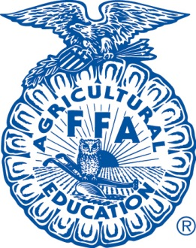
Cypress Falls FFA

Animal Projects
Cy Falls FFA members have numerous opportunities to participate in livestock shows in our surrounding areas. Each show has specific rules and guidelines that are unique to that particular show. Students that show a commitment to their animal projects ad develop a strong understanding of their responsibilities will be given the opportunity to compete at a major livestock shows (Field Trips will have to be approved each year)
If you are raising an animal there are rules that you will have to follow. The majority of our animals will be raised at a district barn (Telge or Eldridge). There are district rules that everyone MUST follow, the rules are in this packet for each district facility.
Raising an animal project is an optional FFA activity. It is highly encouraged among the members as an additional learning activity. We hope everyone in the chapter can make it a “Gold Medal Moment” with their animal project! There will be more information given out in the meeting and in classes, if this is something that you are interested in.
Check Out Policy
In order to help out with some of the expenses of raising an animal, our chapter purchased a few items that re available for check out. These items are not always available, so please make sure you plan ahead. Please see below for the rules
- Items are to be checked out for a period of 5 days only! (Including weekends)
- You MUST check the items out through Mrs. Hernandez or Ms. Baugh
- If you check an item out, you are the person responsible for that item. Even if you are letting someone else borrow the item.
- You will be charged for any missing pieces or damage to the item
- If the item is damaged so bad it doesn’t work, you will have to replace it!
- The item MUST be returned CLEAN!! You will be charged $5, if it is not.
- All fees MUST be paid, or the student will be put on fees and fines at the end of the year.
Items Available for Check out
* Blowers (Cattle, Lamb, & Goats) * Lamb & Goat Stands
* Trim Racks (Cattle) * Blades/Clippers

